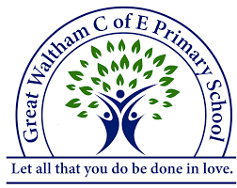
Class South America Topic Web
Summer Term 2026
Curriculum Title – Groundbreaking Greeks

History
This project teaches children about developments and changes over six periods of ancient Greek history, focusing on the city state of Athens in the Classical age, and exploring the lasting legacy of ancient Greece. 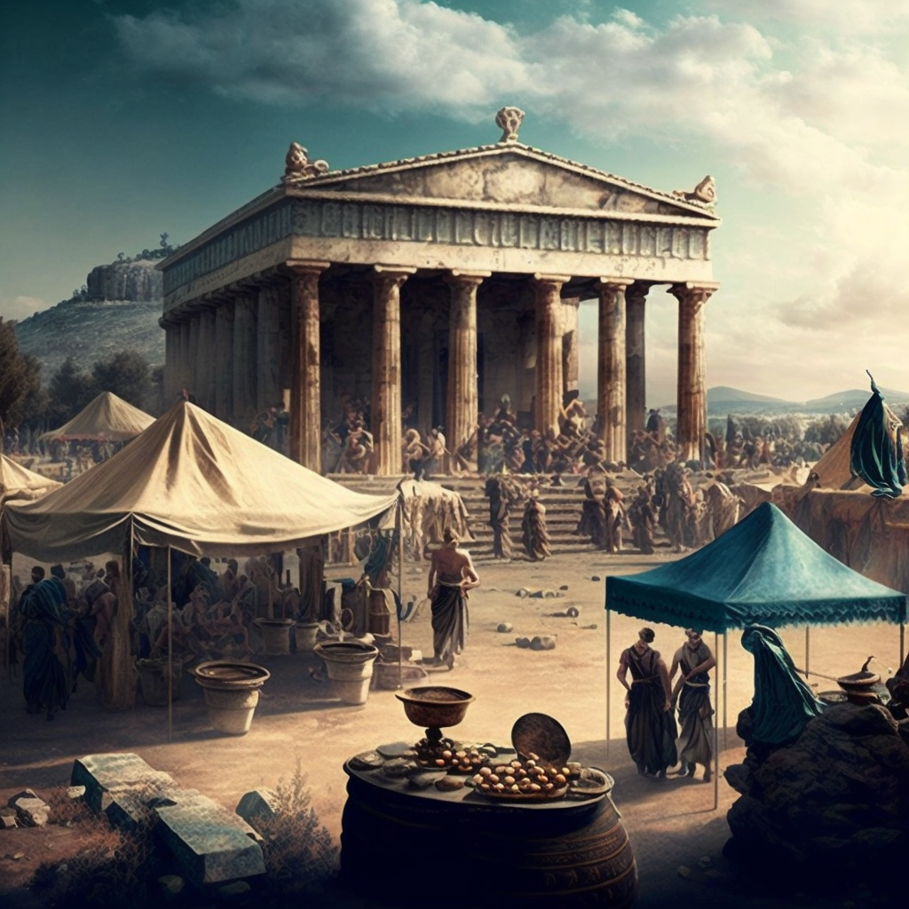

Music
Our music specialist, Mrs Welch, will be teaching the following units across the Summer term:
Freedom to Improvise, Summer Performance Practice, Listening and Appraising, Pictures of an Exhibition

French
This term, we will be broadening our knowledge of the French language through two exciting topics:
- My home
- In the classroom

'Let all that you do be done in love’
Mathematics
In the Summer Term, our maths is organised into sequenced learning blocks comprising of:
Statistics
Pupils interpret and present data using charts and graphs, learning how to read, compare, and draw conclusions from information.
Shape
This unit focuses on identifying, comparing, and classifying 2D and 3D shapes, including understanding angles, lines, and symmetry.
Position and Direction
Children explore how to describe movement and position using coordinates, translation, and directional language.
Decimals
Pupils develop their understanding of decimal numbers, including place value, comparison, and using decimals in calculations.
Negative Numbers
Children are introduced to numbers below zero, learning how to read, compare, and use them in real-life contexts (e.g. temperature).
Converting Units
This unit teaches how to convert between different units of measurement (e.g. length, mass, capacity, and time).
Volume
Pupils learn to measure and compare the amount of space an object takes up, often using cubes and practical resources.

- Using and applying mathematics

English
In the first half term, we will be studying the text, ‘The Lost Book of Adventure’ by Teddy Keen and ‘The Unknown Adventurer.’ The children will work towards producing their own Survival Narrative and Survival Guide. In the second half term, our work will be based on the novel ‘King Kong’, written by Anthony Browne. Pupils will write their own Dilemma Narrative and Balanced Argument.

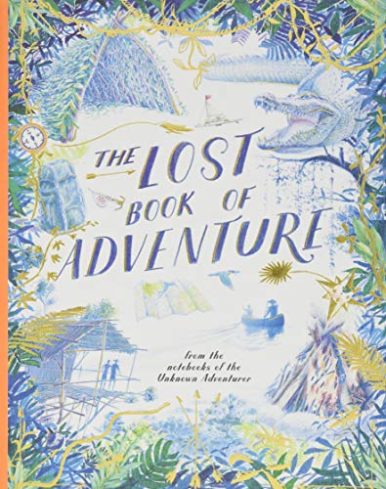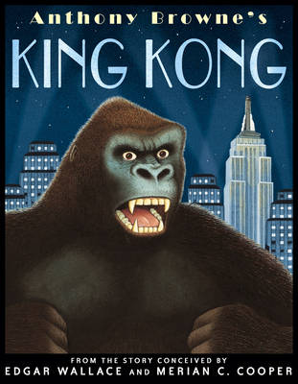

We will have regular reading sessions to embed inference and prediction skills. In addition, we will have a class story book that we will read daily. Reading is an essential skill for learning and this is at the heart of our ethos in class. The children will have short handwriting and spelling sessions throughout the week.

Computing
This term, we will be covering the following topics:
- Vector Graphics
- Selection in Quizzes

Art
In the first half term, our project title is, ‘Mixed Media.’ This project teaches children about paper crafts, papermaking and collage techniques, including paper, fabric, mixed media and photo collage. They use their learning to create a final piece of small-scale, mixed media collage.
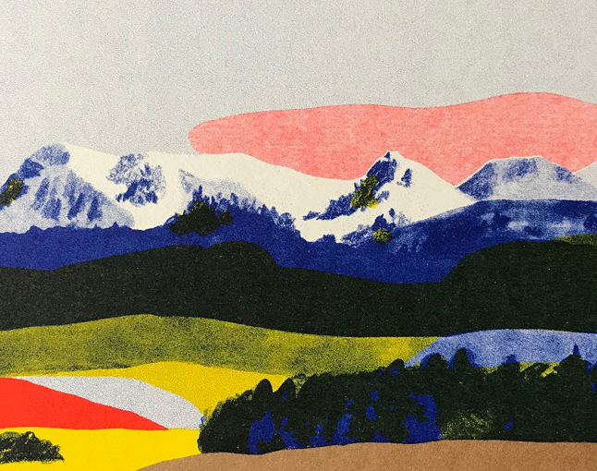
In the second half term, our project title is, ‘Expression.’ This project teaches children about the Expressionist art movement and the 'Father of Expressionism', Edvard Munch. They will explore different ways to portray feelings and emotions in art to create an imaginative self-portrait.

Computing
We will continue to be aware of, and be able to use, the rules for keeping safe on the internet. We will also continue to develop our programming skills. The children will also use computers and iPads to research to support their learning in other areas of the curriculum.
Computing
We will continue to be aware of, and be able to use, the rules for keeping safe on the internet. We will also continue to develop our programming skills. The children will also use computers and iPads to research to support their learning in other areas of the curriculum.
PSHE
PSHE will be taught through three main themes:
- Physical health and mental wellbeing
- Growing and changing
- Keeping safe

P.E.
Pupils will have P.E. on Thursdays and Fridays.
First half term: Athletics and Cricket
Second half term: Rounders and Tag Rugby

DT
Linked closely to our History topic, our unit title for DT is ‘Architecture.’
This project teaches children about how architectural style and technology has developed over time, including Ancient Greek architecture, and then use this knowledge to design a building with specific features.

Science
This term, our project title is, ‘Properties and Changes of Materials.’ This project teaches children about the wider properties of materials and their uses. They learn about mixtures and how they can be separated using sieving, filtration and evaporation. They study reversible and irreversible changes, and use common indicators to identify irreversible changes.
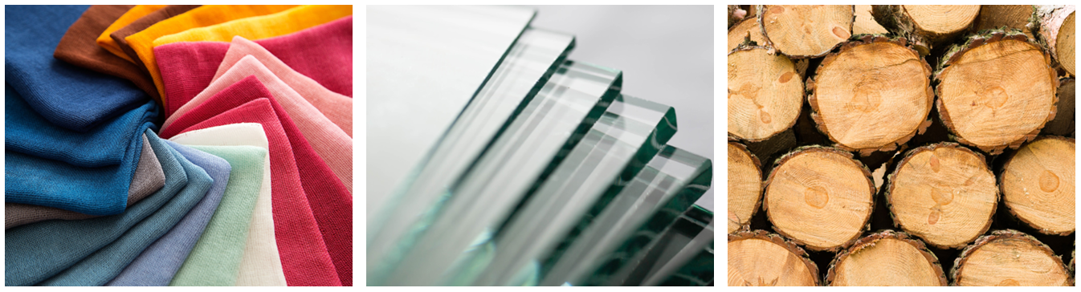

RE
Our RE lessons are based on the new Essex Agreed Syllabus for Religious Education. The syllabus promotes a multi-disciplinary study of religion and worldviews, developing children’s knowledge and curiosity about the world in which they live. It prepares them both for life within the large and diverse County of Essex, but also in the wider world, where they will encounter a huge range of ideas and beliefs.

Our two key questions this term are:
- How can following God bring freedom and justice?
- What matters most to Humanists and Christians?

