Music
Our music specialist, Mrs Welch, will be teaching two exciting units across the Autumn term:
Unit 1: Melody and harmony in music
Unit 2: Sing and play in different styles

PSHE
PSHE will be taught through three main themes; Health and Well-being, Relationships and Living in the Wider World.
In the Autumn term, we will be exploring the following topics:
Families and friendships
Safe relationships
Respecting ourselves and others

French
This term, we will be broadening our knowledge of the French language with two exciting topics:
Unit 1: Dates
Unit 2: ‘At the tea room’

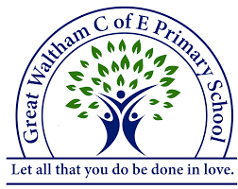
Class South America Topic Web
Autumn Term 2025
Curriculum Title - Dynamic Dynasties
& Investigating Our World

History
Our history topic this term is ‘Dynamic Dynasties.’ This project teaches children about the history of ancient China, focusing primarily on the Shang Dynasty, and explores the lasting legacy of the first five Chinese dynasties, some of which can still be seen in the world today.

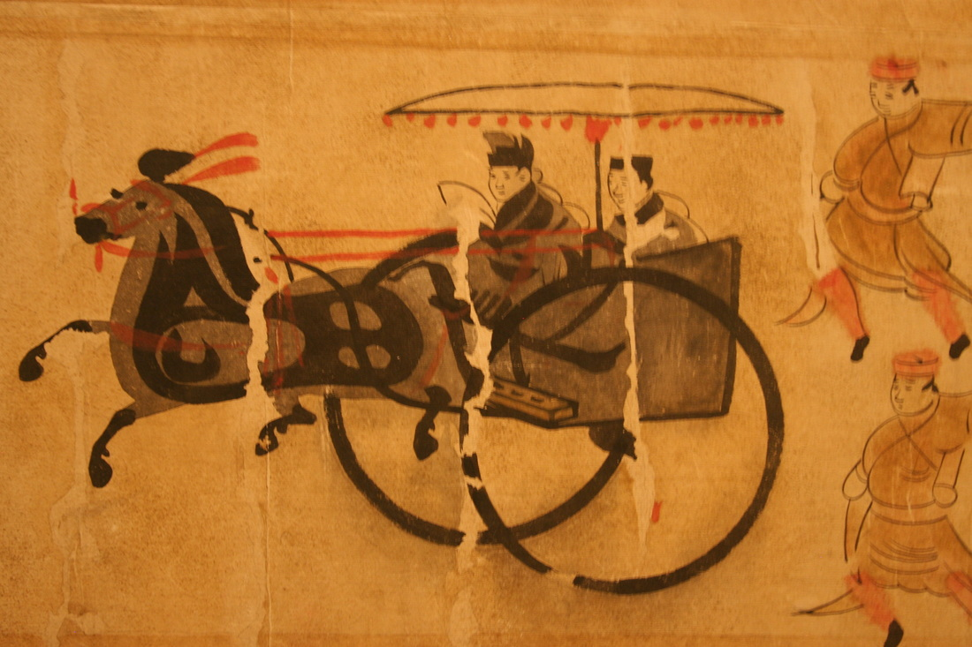
Geography
Our Geography topic this term is ‘Investigating Our World.’ This essential skills and knowledge project teaches children about locating map features using a range of methods. They learn about the Prime Meridian, Greenwich Mean Time (GMT), and worldwide time zones and study interconnected climate zones, vegetation belts and biomes. Children learn about human geography and capital cities worldwide before looking at the UK motorway network and settlements. They carry out an enquiry to identify local settlement types.
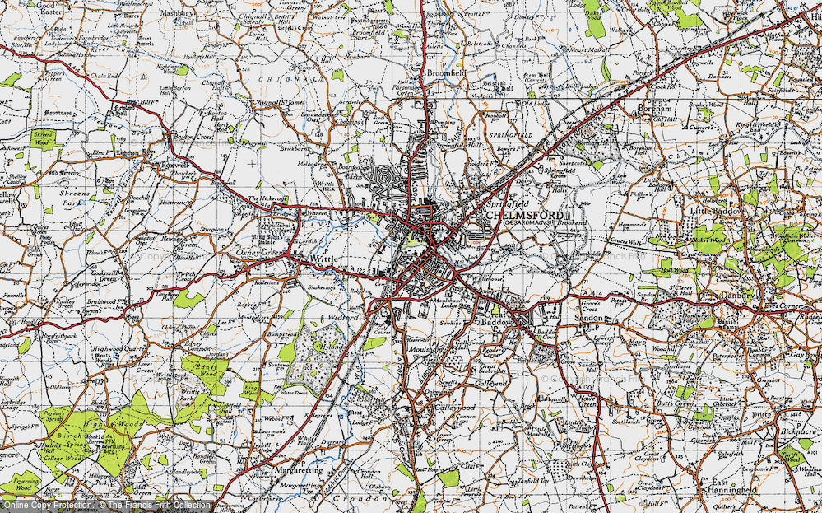

Computing
This term, we will be covering the following topics:
- Systems and searching – How to search the web safely, how search results are ranked and how searches are influenced.
- Video Production – What is video? We will be exploring a range of filming techniques in order to create our own video project.

'Let all that you do be done in love’
Mathematics
In the Autumn Term our maths is organised into 4 key sequenced learning blocks comprising of:
Place value – In this unit, we will be comparing, rounding and exploring place value in numbers to 1,000,000.
Addition and Subtraction - In this unit, we will be developing mental strategies, alongside written methods to solve a range of addition and subtraction problems, including multi-step problems.
Multiplication and Division – In this unit, we will be exploring multiples and factors, prime, square and cube numbers, and also how to multiply and divide by 10, 100 and 1,000.
Fractions – In this unit, pupils will be exploring equivalent fractions, converting improper fractions to mixed numbers and vice versa and comparing, adding and subtracting fractions.

- Using and applying mathematics

Science
Our first topic will be ‘Forces and Mechanisms.’ This project teaches children about the forces of gravity, air resistance, water resistance and friction, with children exploring their effects. They learn about mechanisms, their uses and how they allow a smaller effort to have a greater effect.

Our second topic will be Earth and Space, where we will explore our solar system and its planets.
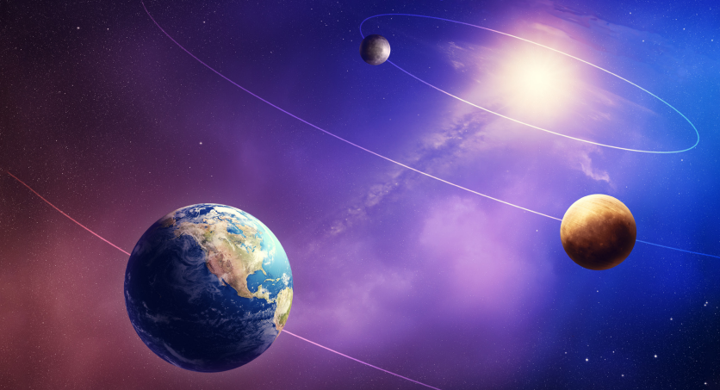

Computing
We will continue to be aware of, and be able to use, the rules for keeping safe on the internet. We will also continue to develop our programming skills. The children will also use computers and iPads to research to support their learning in other areas of the curriculum.
Computing
We will continue to be aware of, and be able to use, the rules for keeping safe on the internet. We will also continue to develop our programming skills. The children will also use computers and iPads to research to support their learning in other areas of the curriculum.
Art
In Autumn 1, our project title is – ‘Colour in Landscape.’ We will be mixing tints, shades and tones and perfecting our sketching skills to create our very own landscape paintings.
In Autumn 2, our project title is – ‘Taoti’
This project teaches children about the significance and art of the taotie motif, including ancient and contemporary casting methods.
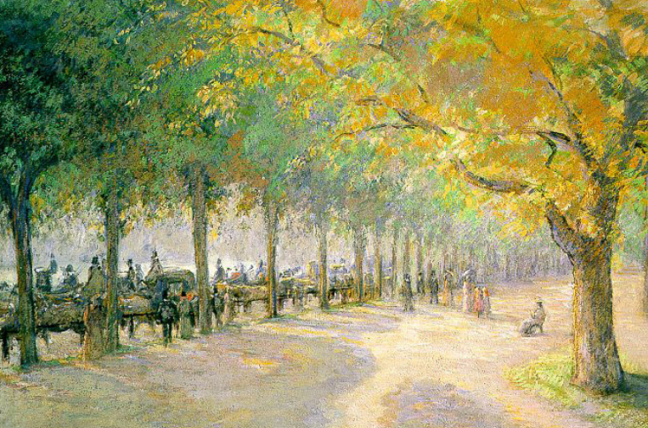

DT
Our unit title is ‘Moving Mechanisms’
This project teaches children about pneumatic systems. They experiment with pneumatics before designing, making and evaluating a pneumatic machine that performs a useful function.

P.E.
Pupils will have P.E. on Mondays and Fridays.
This term, we will be mastering our skills in Hockey, Football, Fitness and Netball.

English
We will be studying the text, ‘When We Walked on the Moon’ by David Long and Sam Kalda. In the second half of the term, our work will be based on the novel ‘FaRther’, written by Grahame Baker-Smith. We will have regular reading sessions to embed inference and prediction skills. In addition, we will have a class story book that we will read daily. Reading is an essential skill for learning and this is at the heart of our ethos in class. The children will have short handwriting and spelling sessions throughout the week.

RE
Our RE lessons are based on the new Essex Agreed Syllabus for Religious Education. The syllabus promotes a multi-disciplinary study of religion and worldviews, developing children’s knowledge and curiosity about the world in which they live. It prepares them both for life within the large and diverse County of Essex, but also in the wider world, where they will encounter a huge range of ideas and beliefs.
Our two key questions this term are:
- What does it mean if Christians believe God is holy and loving?
- What does it mean to be a Muslim in Britain today?

